Application Solution Design
(DCS component moved to SODA Order)
Program/Project Name: ODA Project
Program/Project Number: TB982

Date Saved : 28/08/2012 04:57:00 AM
Author : Ronny Effendi

PROPRIETARY NOTICE

This document contains confidential information. In consideration of receipt of this document, the recipient agrees to maintain such information in confidence and not to disclose this information to any person outside of Optus without the written permission of the author.
Table of Contents
1 Background 3
1.1 Overview 3
1.2 Scope 3
1.2.1 Roles/Actors 3
1.2.2 Tasks 3
2 Application Solution Detail 4
2.1 Overview 4
2.2 Impacts 5
2.3 Host Information 5
2.4 Data Volume 6
2.5 File Naming Convention 7
2.5.1 TSA Files 7
2.5.2 IDW Format 8
2.6 Other Solution Options Considered 9
Appendix A. Definitions and Acronyms 10
Appendix B. Document Control and Approval 11
B.1 Responsibilities 11
B.2 Approvals 11
B.3 Review Record 11
B.4 Version Control 12
B.5 Reference Documents 12
B.6 Related Documents 12
Appendix C. Sample TSA Reports 13
Appendix D. IDW Filenaming Convention 14

Background

Overview
The Optus Digital Agency (ODA) project is an initiative to provide a range of digital advertising solutions to Optus SMB customers. The goal and vision is to create a one-stop shop for SMB customers to purchase online advertising (presence and relevance) tools and services for the SMB to generate cost effective sales leads via the web. Specifically, postpaid SOHO and micro-SMB segments are the target. The 3rd parties NCS, Melbourne IT, TSA and Google will be engaged to support this initiative. The product will initially be sold via the SMB Telesales and Call Centre channels.
ODA has gone live in July 2012 with the initial solution where TSA sends four files into IDW via DCS. InfoSec has given approval for this solution for the duration of three months. After then, the solution is to be migrated out of DCS into other system. SODA Order is now identified as the replacement for this purpose
This overview is intended to set the context for the solution description and should be kept brief (< 1/4 page) and should describe (as appropriate):
The Business Case
The Business Drivers
The expected solution outcomes of the program
The role that the changes to this component plays in the overall solution
Business drivers may include:
• Increased productivity
• Reduced costs, increased competitive advantage (pro-active or re-active)
• Increased revenue or market share
• Improved service
• Response to mandatory governmental or other directives
• Unsatisfactory characteristics of the current system (eg. support / performance)

Scope
The scope of this Solution Design is for the TSA, SODA Order and IDW components. SODA Order will be used to pass into IDW, the weekly statistical SMB website and campaign information that are provided by TSA.
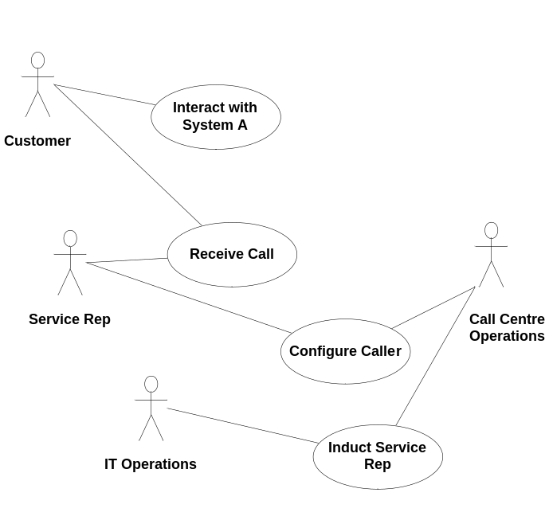
Figure 2 Project ABC Scope

Roles/Actors

TSA
Provide weekly reports containing statistical information relevant to Optus SMB website and campaign. This will be left unchanged from the existing functionality
Role description.

SODA Order
SODA Order will pull the files into TSA server and transform the file name into IDW. These files then need to be sent to IDW

IDW
IDW will store the weekly SMB website statistical and charges reports, and make available to Business for analysis. This will also be left unchanged from the existing functionality

Tasks
- SODA Order pulls the files from TSA, transform into IDW format and push the files into IDW server
Task description.
Identify the constraints that relate to the configuration and operations, eg. Particular backup & recovery or disaster recovery requirements
This section describes the impacts that the development methodology for the project (eg iterative, multi-phase, combination thereof, etc) will have on the manner that the solution will be implemented (eg. Which set of basic components/features are required to be developed first to provide an initial delivery, etc).

Application Solution Detail

Overview
Intermediate (DCS) currently pulls reporting files from TSA and formats the file name into IDW file naming format. DCS will then send these files into IDW.
InfoSec only gives approval for this approach for 3 months after the initial implementation. InfoSec has recommended moving these interfaces out of DCS after 3 months of implementation
The following is the new solution proposed:
- TSA to continue generating the data-feed files on weekly basis. These files will remain in the csv format
- SODA Order will replace DCS to perform:
  - Pull the data-feed files from TSA server
  - Rename the data-feed files into IDW format and populate with the right sequence number
  - Send those files into IDW
- IDW to continue processing TSA files like it does today
The following diagram shows the difference between the current and proposed solutions.

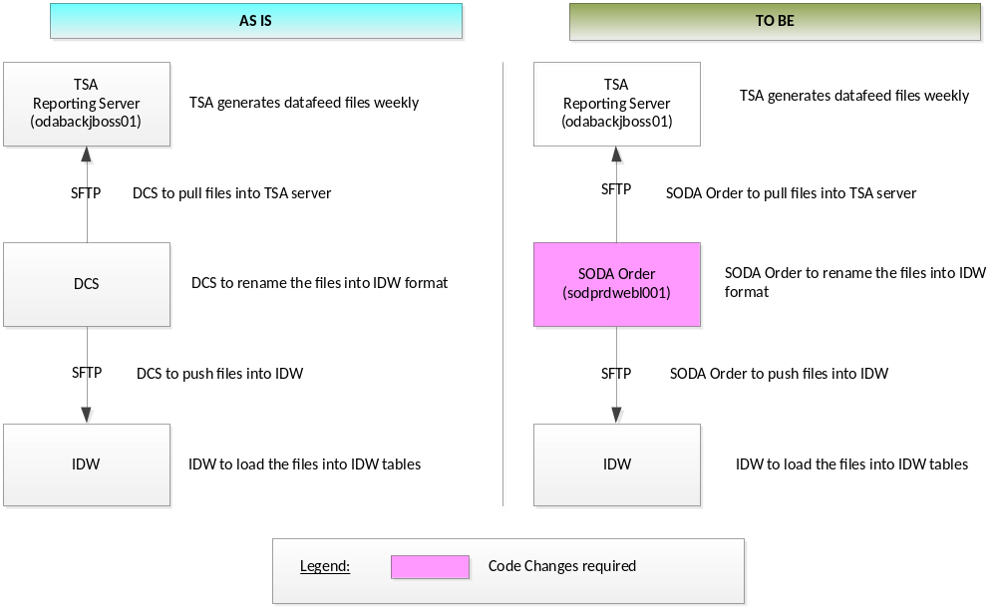
This section contains the solution details for the specific application component(s). Provide a UML component diagram to illustrate the scope of the component solution to be delivered, identifying any interfaces involved.
For IDW this section should include the Data flow diagram (DFD). IDW will present interfaces as interaction scenarios within section 5.2
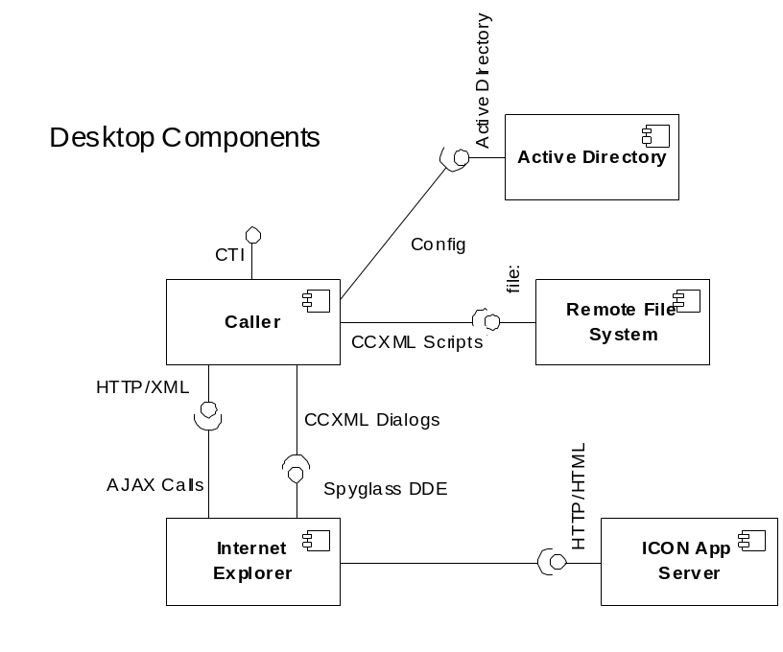
Figure 3 UML Component diagram depicting the solution overview
Provide a description of interaction scenario N with a supporting UML Interaction diagram.

Impacts
Using the table below (or similar), describe the key impacts that the proposed changes to the relevant components will have upon other existing systems, components and interfaces
For IDW this includes downstream impacts eg impacts on ICON, SOS SQ and Planscan
IT System/ Component/ Interface | Impact | Description of Impact | Note
TSA | No Impact | - TSA to continue creating data-feed files as per current
SODA Order | Code Changes | - Pull data-feed files from TSA server  - Rename the file name into IDW format  - Send the data-feed files into IDW
IDW | Documentation | - No changes in IDW  - IDW to continue the existing process for TSA files (IE – Source System)  - IC and documentation to be updated to reflect the new changes (moving out of DCS into SODA Order)
DCS | Documentation  Code Changes / Config | - To decommission or disable TSA interfaces  - IC and documentation to be updated to reflect the new changes (moving out of DCS into SODA Order)
Data Volume

Host Information
Environment | TSA | SODA Order | IDW
SIT | Location: Mascot – Tier 3  Hostname: odabackjboss01.sit.optusnet.com.au  IP: 10.127.87.230  Port No: TCP:22  Directory: /home/optus/datafeeds | Location: SPOC  Hostname: sodsitwebl001.optus.com.au  IP: 161.43.5.21  Port: TCP:22 | Hostname: optusdw2-b  IP: 161.43.5.111  Port: TCP:22  Username : SFTP: ftpie  Dev Directory: /staging/landing/dev/ie/pub2  SIT Directory: /staging/landing/test/ie/pub2  UAT Directory: /staging/landing/test/ie/pub2  Pre-Prod Directory: /staging/landing/prod/ie/pub2
PPT | Location: Mascot – Tier 3  Hostname: odabackjboss01.prep.optusnet.com.au  IP: 10.127.87.234  Port: TCP:22  Directory: /home/optus/datafeeds | Location: SPOC  Hostname: sodpptwebl001.optus.com.au  IP: 10.10.37.247  Port: TCP:22 | Hostname: optusdw2-b  IP: 161.43.5.111  Port: TCP:22  Username : SFTP: ftpie  Dev Directory: /staging/landing/dev/ie/pub2  SIT Directory: /staging/landing/test/ie/pub2  UAT Directory: /staging/landing/test/ie/pub2  Pre-Prod Directory: /staging/landing/prod/ie/pub2
Prod | Location: Mascot – Tier 3  Hostname: odabackjboss01.syd.optusnet.com.au  IP: 10.255.162.12  Port: TCP:22  Directory: /home/optus/datafeeds | Location: CHOC  Hostname: sodprdwebl001.optus.com.au  IP: 10.8.36.207  Port: TCP:22 | Hostname: csgi1471.optus.com.au  IP: 161.43.16.186  Port: TCP:22  Username : SFTP: ftpie  Directory: /staging/landing/prod/ie/pub2
Data Volume Data Volume
Using the table below (or similar), describe the elements of the solution that address any reporting and/or ad-hoc access requirements identified in the DRS and elsewhere eg. Standard operating procedures and identify which component will deliver this feature
Where they exist, insertion of references to the pertinent section of the component solution design specification(s) would be appropriate here.
For IDW this includes both requirements driven and technical reports (eg load error reports)

Data Volume
Where they exist, insertion of references to the pertinent sections in the sub-sections below of either the application or infrastructure solution design specification(s) would be appropriate
The TSA files are provided weekly. The aggregate number of records in the files is expected to be no more than 250,000 records.
Estimated size for each interface is as followed:
  - ACPRFS – Account Performance Summary (~ 68 bytes, 137 kB (approx. 10,000 records) per week )
  - ACPRFD – Account Performance Summary By Distribution (~80 bytes, 1.5 MB (approx.. 20,000 records) per week )
  - BUARSM – Business Area Performance Summary (~ 52 bytes, 51 kB (approx. 1,000 records) per week )
  - CMPSTS – Campaign Status (~ 62 bytes, 6 MB (approx.. 100,000 records) per week
This section describes the anticipated application performance of any new or changed applications and is required for all developments. The discussion should cover the following aspects from a high level perspective and highlight any issues relating to performance impacts or performance assumptions:
• Response times (ie. time required for the user to receive a response)
• Run times (ie. time required to perform a batch process)
• Service time (ie. time required to perform asynchronous operations, for example Order time to process one order)
• Availability requirements (ie. amount of time that the application is available for business operation)
• User load - average & maximum
• Application workload - average & maximum
• Application throughput (ie. messages per second, transaction per second, disk utilisation) - average & maximum
• Resource utilisation (CPU, memory, I/O) - average & maximum

This section describes the anticipated hardware performance considerations and any hardware performance issues that may affect the hardware-application interface from a high level perspective and should include:
• User load - average & maximum
• CPU, Memory & IO resource utilisation - average & maximum

File Naming Convention

TSA Files
Each TSA file name uses the following format:
<prefix>_<start date>_<end date>_<generation date and time>.<extension>
where:
<prefix> values are:
Interface File | <prefix> value
Account Performance Summary | AcctPerfSum
Account Performance Summary by Distribution | AcctPerfDist
Business Area Performance Summary | BusAreaPerf
Campaign Status Summary | CampStatus
<start date> is the starting date for the enclosed data. Format: YYYY-MM-DD
<end date> is the ending date for the enclosed data. Format: YYYY-MM-DD.
<generation date and time> is the date/time stamp when the file was generated. Format: YYYY-MM-DD_HHMMSS.
<extension>
Each interface file will be created in compressed format (.zip extension)
After a zipped file is created, another file with zero byte size with the same name except with an additional .done extension will also be created in TSA server is to indicate the file is ready to be picked up. DCS sftp “pull” script should check for the existence of this .done extension before proceeding with copying the file into DCS server.
After a file has been transferred, DCS sftp script will rename both files extension (.zip and .zip.done) with additional .grabbed extension (becoming .zip.grabbed and .zip.done.grabbed) so that it is clear the files have been pulled and will leave no ambiguity. Also, this will also allow us to filter out any files that have been grabbed previously.
Example:
Before transfer:
AcctPerfSum_2012-04-17_2012-04-22_2012-04-21_120000.zip <- Data file
AcctPerfSum_2012-04-17_2012-04-22_2012-04-21_120000.zip.done <- zero byte file
After transfer:
AcctPerfSum_2012-04-17_2012-04-22_2012-04-21_120000.zip.grabbed
AcctPerfSum_2012-04-17_2012-04-22_2012-04-21_120000.zip.done.grabbed

IDW Format
SODA Order should rename the data-feed file to conform into the following IDW format:
<SourceSys>_<ExtractDate>_<RunNbr>_<FileType>_<SchedSeqNbr>_<SubFileSeqNbr>_<BlockNbr>_<VerNbr>.DAT, where:
SourceSys | Default to “IE”
ExtractDate | The date of the extract in YYYYMMDD format. This is set to the date when the extract commences. All files in the set must contain the same date, as part of the filename.
RunNbr | Default to “000000”
FileType | File identifier – a 6-character identifier for the file type.  ACPRFS – Account Performance Summary  ACPRFD – Account Performance Summary By Distribution  BUARSM – Business Area Performance Summary  CMPSTS – Campaign Status
SchedSeqNbr | Schedule Sequence Number – a 6-digit number left filled with zeros. The schedule number shall begin at “000001” for the initial data-feed and be incremented by 1 for each schedule executed and will not be reset. It is the sequence number for the particular file type.  TSA should maintain sequence number for each file
SubFileSeqNbr | Default to “001”
VerNbr | Default to “00”
BlockNbr | Default to “01”
An Output Transmittal Report will not be sent.
Neither a ‘control’ file nor an ‘end of transmission’ file will be sent.
The files will be pushed to the IDW directory /staging/landing/prod/ie/pub2 from SODA Order

Examples:
Previously, the following file name was created in TSA:
AcctPerfSum_2012-07-30_2012-08-05_2012-08-12_030000.zip
AcctPerfDist_2012-07-30_2012-08-05_2012-08-12_030000.zip
BusAreaPerf_2012-07-30_2012-08-05_2012-08-12_030000.zip
CampStatus_2012-07-30_2012-08-05_2012-08-12_030000.zip
SODA Order now needs to rename those files into the following:
IE_20120813_000000_ACPRFS_000004_001_00_01.DAT
IE_20120813_000000_ACPRFD_000004_001_00_01.DAT
IE_20120813_000000_BUARSM_000001_001_00_01.DAT
IE_20120813_000000_CMPSTS_000001_001_00_01.DAT

Other Solution Options Considered
Initially, OFT was the candidate as an option to replace DCS to send the files from TSA into IDW. However, the following reasons have been identified which caused this solution not feasible:
- OFT will only perform file transfer. The process of renaming of TSA files into IDW format and maintaining the right sequence still needs to be done in other system outside OFT. Ideally TSA should perform this functionality
- As TSA will mainly generate the data-feed files in its own format, there is a gap on how the file needs to be renamed into IDW format
This section is a high-level description of the components of the solution that will address data issues relating to the creation of a new system and migration of data from an exiting system that is being made obsolete. The aspects to consider here are
• Population of the new data elements at start-up
• Conversion of data formats from the old to the new system format
• Migration of converted data to the new system
Where they exist, insertion of references to the pertinent section of the component solution design specification(s) would be appropriate here
Describe at a high level the operational security Implications of the proposed solution including:
• User / Group
• Security Access Level (Add / Maintain / Delete / Read Only)
Where they exist, insertion of references to the pertinent section of the component solution design specification(s) would be appropriate here.
- Definitions and Acronyms
Acronym /  Term /Notation | Description
DCS | Data Collection System, renamed Intermediate
DRS | Detailed Requirements Specification
FTP | File Transfer Protocol
IDW | Integrated Data Warehouse
Intermediate | Optus mediation platform for wireline and mobile voice and SMS usage, also known as DCS
SFTP | Secure FTP
SODA Order | Optus system that is used to manage ODA order
TSA | The Search Agency
- Document Control and Approval
  - Responsibilities
Responsibilities for this document have been assigned as follows:
Role | Responsibility | Assigned to | Position
Document Owner | Overall responsibility for document accuracy and distribution list. | Ronny Effendi | Principal Designer
Document Author | Prepare the document to the Document Owner's specification. | Ronny Effendi | Solution Designer
Document Controller | Version control and distribution to nominated document holders. | Ronny Effendi | Solution Designer
Address of Document Controller | Optus Singtel Pty Ltd  1 Lyon Park Road, MacQualrie Park, NSW 2113
Copyright | This material is copyright. No part of this document may be reproduced in any form, stored in a retrieval system or transmitted without the prior written permission of Optus.
Confidentiality | This document is classified Commercial in Confidence. It is subject to a confidentiality agreement between the recipient organisation and Optus. Its contents must not be divulged to third parties.
  - Approvals
The appropriate representatives from my team have reviewed this document and I authorise it for issue
Name | Title | Signature | Date
Peter Louis | Architecture & Design Manager – Core Platforms
Dante Lorredo | IT Project Manager

  - Review Record

Review Procedure  Review [R] or Walkthrough [W] | Version No. | Date Accepted | File Location
  - Version Control

Version | Date | Section | Nature of Amendment | Amendment Author
0.1 | 21/08/2012 | All | Initial version | Ronny Effendi
  - Reference Documents

Reference Document | Version | Date | File Location
ODA E2E Solution Design |  |  | http://odmprdappw001.optus.com.au/livelink/livelink.exe?func=ll&objaction=overview&objid=30633288
  - Related Documents
The following documents should be read in conjunction with this Solution Design
Related Document | Version | Date | File Location
IC – TSA to DCS v0.5 | 0.5 | 23rd Jul 2012 | 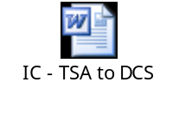
IC – DCS to IDW | 3.4 | 21st Aug 2012 | 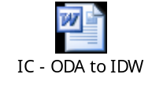
Optus Data Feed Specification (From TSA) |  |  | 

- Sample TSA Reports


- IDW Filenaming Convention

